Call for Applications
Application form

Sustainability and decent work support programme for business support organisations

Trade for Development Centre
Contracting authority: Enabel, the Belgian development agency

Reference : BEL2201011
Application deadline: 16 September 2024 at 12.30pm (Belgian time)
Submission via : https://submit.link/2Ls

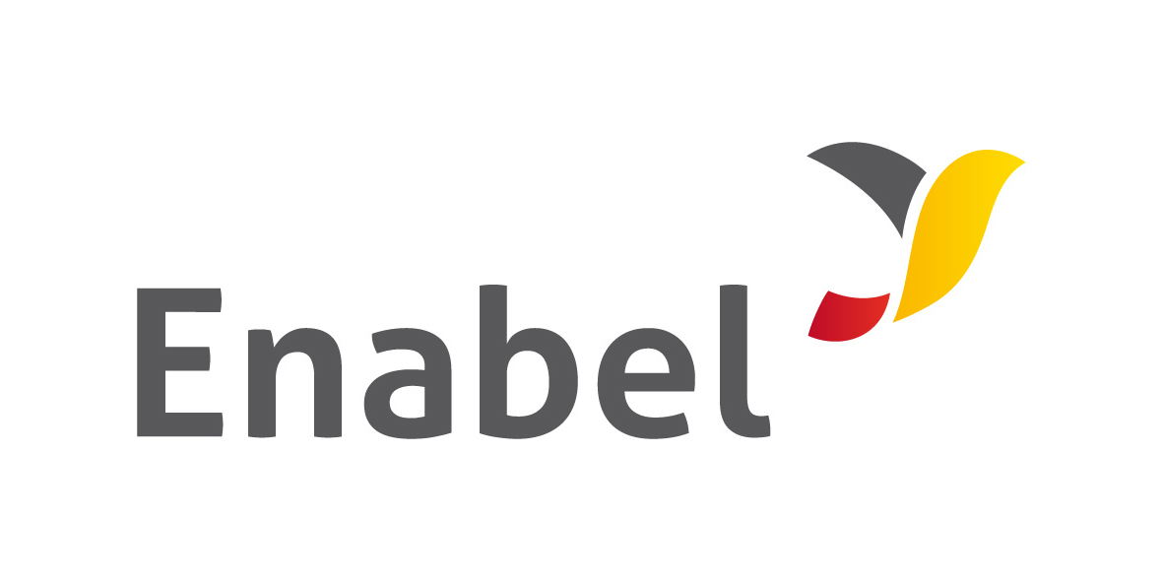 | 

CONTENTS

1. GENERAL INFORMATION ABOUT THE APPLICANT ORGANISATION 3
2. ELIGIBILITY CRITERIA 4
3. MOTIVATIONS 6
4. SELECTION CRITERIA 8
5. DOCUMENTS TO BE SUBMITTED - MANDATORY 10
6. DECLARATION UPON HONOUR 11

**********************************************************************************
Prior to filling out the application form,
please read the document “Call for Proposal – Content, rules & regulations”
**********************************************************************************

For any question, please send an e-mail to tdc@enabel.be

GENERAL INFORMATION ABOUT THE APPLICANT ORGANISATION

Contact details
Name of the organisation
Postal address
Physical address (localisation of the office)
Contact person(s) + position within the organisation
Telephone number: country code + city code + number
E-mail address(es) of contact person(s)
Name of the person and position of the person who completed this form
Website

Short presentation
Explain briefly the origin and evolution of the organisation | (max 30 lines)

ELIGIBILITY CRITERIA
If you do not meet all the criteria below with the minimums
indicated in the file “Content, rules & regulations”,
it means that your organisation is NOT eligible
Object/purpose of the company:
- At what stage(s) of a company's life do you intervene (creation, growth, development,...)? Explain.
- In which areas do you provide advice (legal, management, financial, commercial,...)? Explain.
Type of services provided:
- What type of services do you provide to your clients (advice, training, coaching,...)? Explain.
Legal form:
- What is the legal form of your organisation?
- Is it considered as private, public or parapublic company?
Establishment:
- When was your organization officially created?
Type of clients:
- What type of customers/beneficiaries do you support?
- Do you support cooperatives/producers’ organisations/social enterprises? Explain.
Volume of customers
- How many structures did you support in 2021?
- How many structures did you support in 2022?
- How many structures did you support in 2023?
Geographical area :
- Where is your head office located?
Support from TDC
- Have you ever received support from the TDC (if so, please specify)?

Human resources that have been part of the organisation since JANUARY 2022

Permanent / fixed contracts
Name | Hired on...  (and left on... if no longer working for the organisation) | Function/profile/skills
…
External consultants (if any)
Name | Has been working with us since....  (specify if worked in 2022, 2023 but no longer works for the organisation) | Function/profile/skills
…

Do the managers speak fluently French or English?

- MOTIVATIONS

What are, according to you, your 3 biggest strengths ?
1.
2.
3.
What are, according to you, your 3 biggest weaknesses ?
1.
2.
3.
Explain why you ask this support. What are your expectations? (maximum 20 lines)

What are your reinforcement needs? Prioritize
(see paragraph "Presentation of the reinforcement programme offered by the TDC" on page 3 in the contents & regulations)
Order of importance | Type of need | Explain and specify if you have already received any support in this area
Need n°1
Need n°2
Need n°3
...

How do you see your organisation evolving? Where do you see your organisation in 5 years’ time, for example? What is your dream?

SELECTION CRITERIA

Customer :  - Is the number of supported cooperatives/producers’ organizations increasing? | Explain, quantify
- If so, do you have a specific strategy to reach/accompany this target?
- Are you active in sustainable trade? Social economy/business? (asset*)
- Are you active in the following sectors: cocoa, coffee or cashew nuts? (asset*)
Business volume (customers, projects)  - Has your business volume increased? | Please explain the reasons for a decrease, stagnation or increase
- Are you actively looking for new customers, or are customers coming towards you? | Explain
Services offered  - Have you diversified/improved the services that you offer? | Yes/no, explain the reasons
Matching of your services with the needs of your beneficiaries  - How do the services offered correspond to the needs and challenges faced by those you support? | Explain
Communication  - Do you have communication tools? | Yes/no, detail
Local anchoring / network  - Who are your most important partners? And what kind of partnership is it? | Explain
- Are you a member of any organisation?
- Are other organisations member of your organisation?
- Do you have offices in rural areas? (asset*) | If you do, where are they located?

 | 2022 | 2023 | 2024 (forecast) | 2025 (forecast)
Turnover
Grants (if any)
Gross operating margin
Net result before taxes
Number of full time equivalent jobs

Turnover  - At what daily rate (or other) do you invoice your services? | Please explain
Funding sources
- What are your different sources of funding?
- Do you have bank loans? If so, what type of loan is it?

DOCUMENTS TO BE SUBMITTED - MANDATORY

- This document, duly completed, and signed by the director of the organisation
- The legal entity form (Annex B)
- The statutes (bylaws, articles of association)
- The financial statements (Profit & Loss Account + Balance Sheet) for the previous two years years: 2021 & 2022 (or 2022 & 2023 if 2023 is already available)
- A track record detailing the support that has been delivered to 2 supported organisations in 2021 or 2022 or 2023 including ALL THE FOLLOWING PARTS:
  - the methodology used,
  - the tools created,
  - the reports exchanged between the BSO and the coached company,
  - the amount invoiced,
  - the number of days worked,
  - the profile of the persons who intervened in the case.

If available, please also submit your:
- Organisational chart
- Promotion and communication material
- Marketing plan
- Business plan

DECLARATION UPON HONOUR
DECLARATION UPON HONOUR THAT ALL INFORMATION PROVIDED IS CORRECT AND TRUE

The organization certifies that it is not in one of the exclusion situations mentioned in chapter 4 of the document "Call for Proposal - Content, rules & regulations".

DATE

NAME of director

Signature

